**Muhammad Talha Ramzan**

**2330-0141**

**Bs Ai**

**Task no 01**

we built a small network in which we sent a packet to a selected device. In this network, we used a switch and connected three computers, assigning each computer a different IP address.

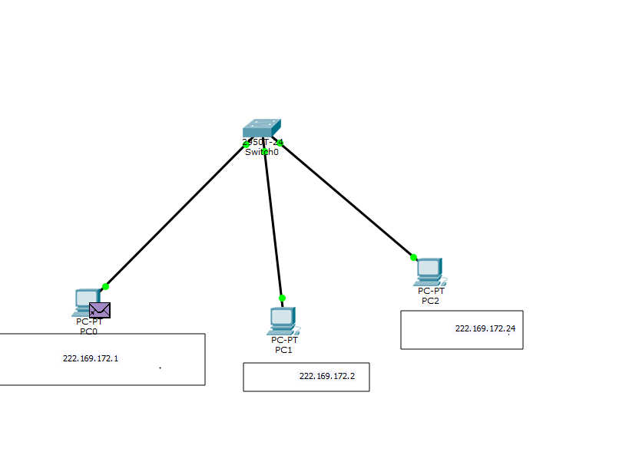

We successfully sent a packet to a selected device



Next, we configured the switch and used the command to show the MAC address. Then, we entered the following commands:

1. enable
2. configure terminal
3. hostname myswitch
4. exit
5. To show the MAC address, use: show mac address-table

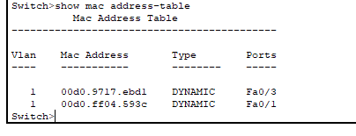

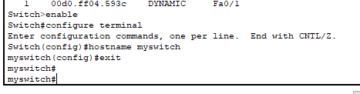

**Task no 02**

In Task 2, we added another switch and connected three computers to it, with each computer having its own IP address. On the other side, we performed the same setup

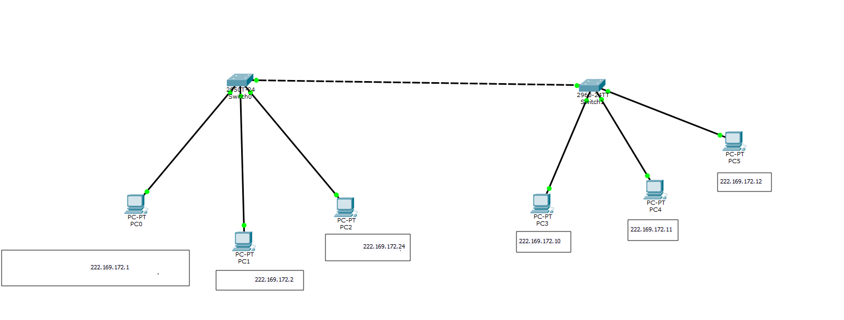

We first connected two switches, then connected one switch to a computer and sent a packet to the computer on the other switch, which was successfully received.

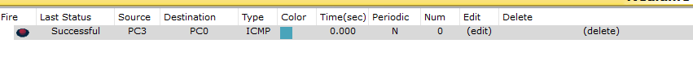

After successful send pkg update the mack address

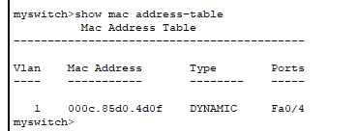

**Question no 3**

